D-R-1 versus D-R-3 Efficiency Reporting Explained

Standard Hours = Estimated MR Hours + Calculate Standard Run Hours

Standard / Actual Hours = Efficiency Percent

D-R-1 Actual Hours includes Charged Downtime.

D-R-3 Actual Hours excludes Charged Downtime.

D-R-3 Prints just 1 decimal position which is rounded to fit data, hence percentages are higher.

Job Sample below assumes job make ready hours are .50 and standard run speed of 1100 in the job file.

D-R-1 Report

Standard run hours for run quantity of 1470 / 1100 = 1.336 + .5 MR = 1.836 rounded to 1.84 on DR1.

Actual Hours include Charged Downtime. Columns have 2 Decimals, thus are more accurate.

Total Actual Hours = MR+ RUN + DT = 1.45 + 3.22 + 1.03 = 5.70

D-R-1 Percent Efficiency 1.84 / 5.70 = 32.28 %

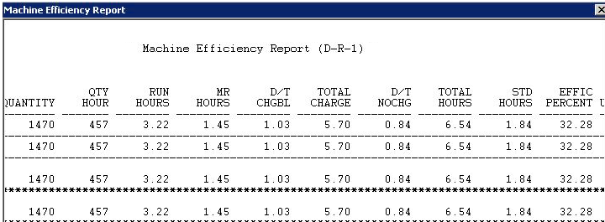

D-R-3 Report

Actual Hours include Charged Downtime. Columns have 1 Decimals, thus are rounded up.

Total Actual Hours = 4.7 = MR is rounded from 1.45 to 1.5 and run hours are rounded to 3.2

Standard Hours Rounded = .5 MR + 1.3 rounded down from 1.33

Efficiency = 1.8 / 4.7 = 38.29 rounded up to 39%

All hours are 1 decimal so they are rounded which makes the Percentages higher.

Also, downtime is excluded from Efficiency on D-R-3

